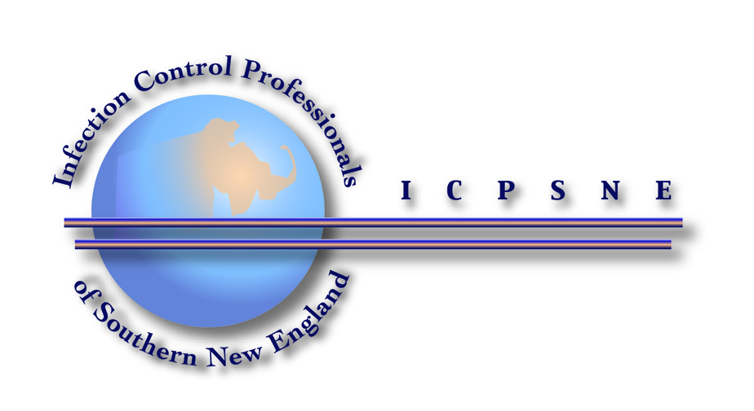
Infection Control – Spanning the Continuum of Healthcare
November 16, 2017

Sponsors

EBP Supply Solutions

Healthcentric Advisors

HIIN

PDI

Surfacide

EBP Supply Solutions

Healthcentric Advisors

HIIN

PDI

Exhibitors

Ethicon

Global Life Technologies

GoJo Industries, Inc.

Halyard Health

Health Care Technology

ICP Medical

Molnlyke Health Care

Pall Medical

PDI

ReadyDock, Inc.

Ryan Medical

Seal Shield

Steadmed Medical LLC.

Stericycle

Surfacide

Symmetry Hand Hygiene

Teleflex Arrow Vascular Access

Tru-D Smart UVC

Allston Supply Company

Argentum Medical

Bard Medical

Cintas

Clorox Company, HC Division

Coloplast

Cook Medical

Curtain Care Plus

Custom Technology

Dale Medical Products

DebMed

Diversey, Inc.

East Side Clinical Laboratory

Ecolab

EBP Supply Solutions

EcoLab

Eloquest Ferndale Laboratories

